(Team 6)

**(Classmate)**

Software Design Document

Srivathssan VV(19z247)

Kousik Nibith Ram V P(19z253)

Vignesh M (19z258)

Sruthi S(20z434)

Udhayakumaran H (20z435)

Vignesh A(20z436)

Date: (28/09/2021)

**TABLE OF CONTENTS**

1. **INTRODUCTION**2

#### Purpose

* 1. Scope
  2. Overview

1. **UML DIAGRAMS** 2

#### Use-case Diagram

* 1. Class Diagram
  2. Sequence Diagram
  3. Activity Diagram

1. **APPENDIX** 10
2. **INTRODUCTION**
   1. **Purpose**

The Purpose of this project Classmate is to help students and teachers connect virtually and pursue their education

### Scope

This project attempts to connect teachers and students via online .This platform allows teachers to schedule tests and webinars and allows students to answer scripts

The teachers can grade those answer scripts and mark attendance for webinars

### Overview

This design document contains UML diagrams like Class diagram, Sequence diagram, Activity diagram, Use-case diagram

1. **UML DIAGRAMS**
   1. **Use-case diagram**

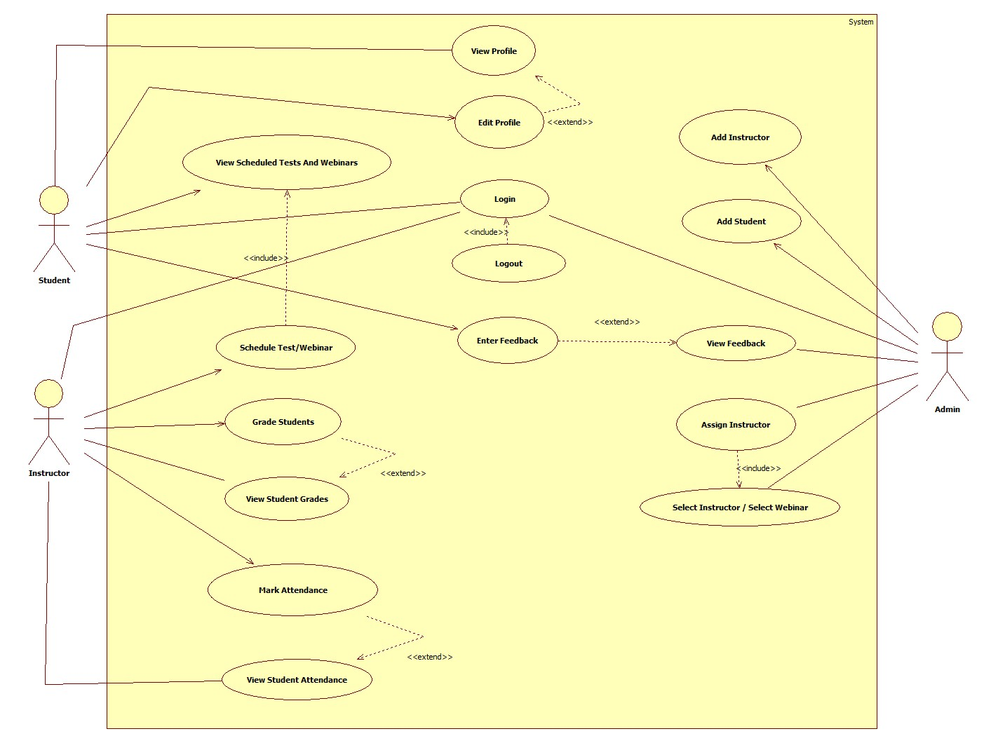

* 1. **Class diagram**

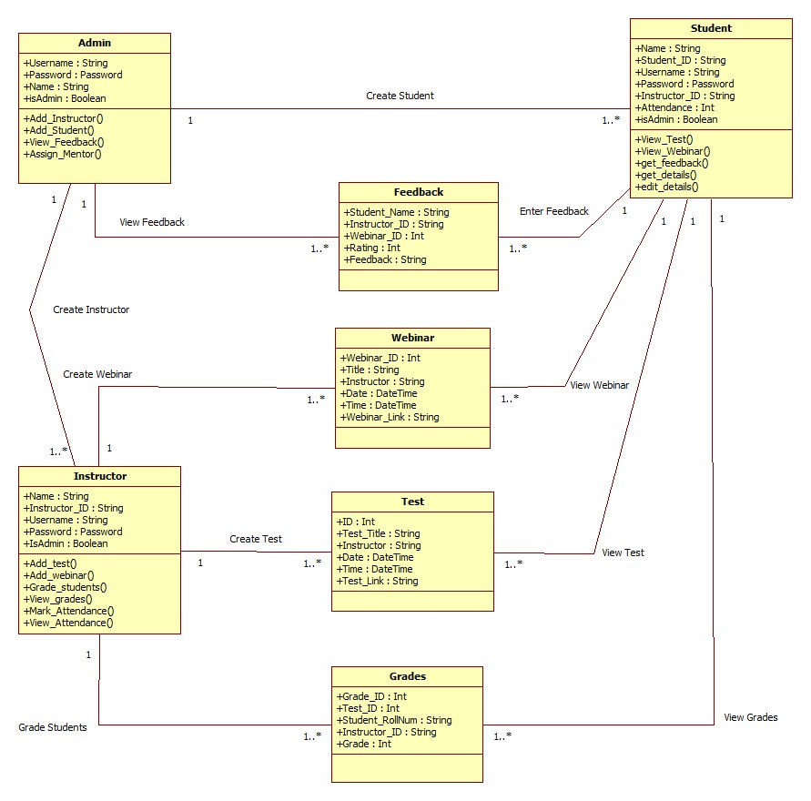

* 1. **Sequence diagram**

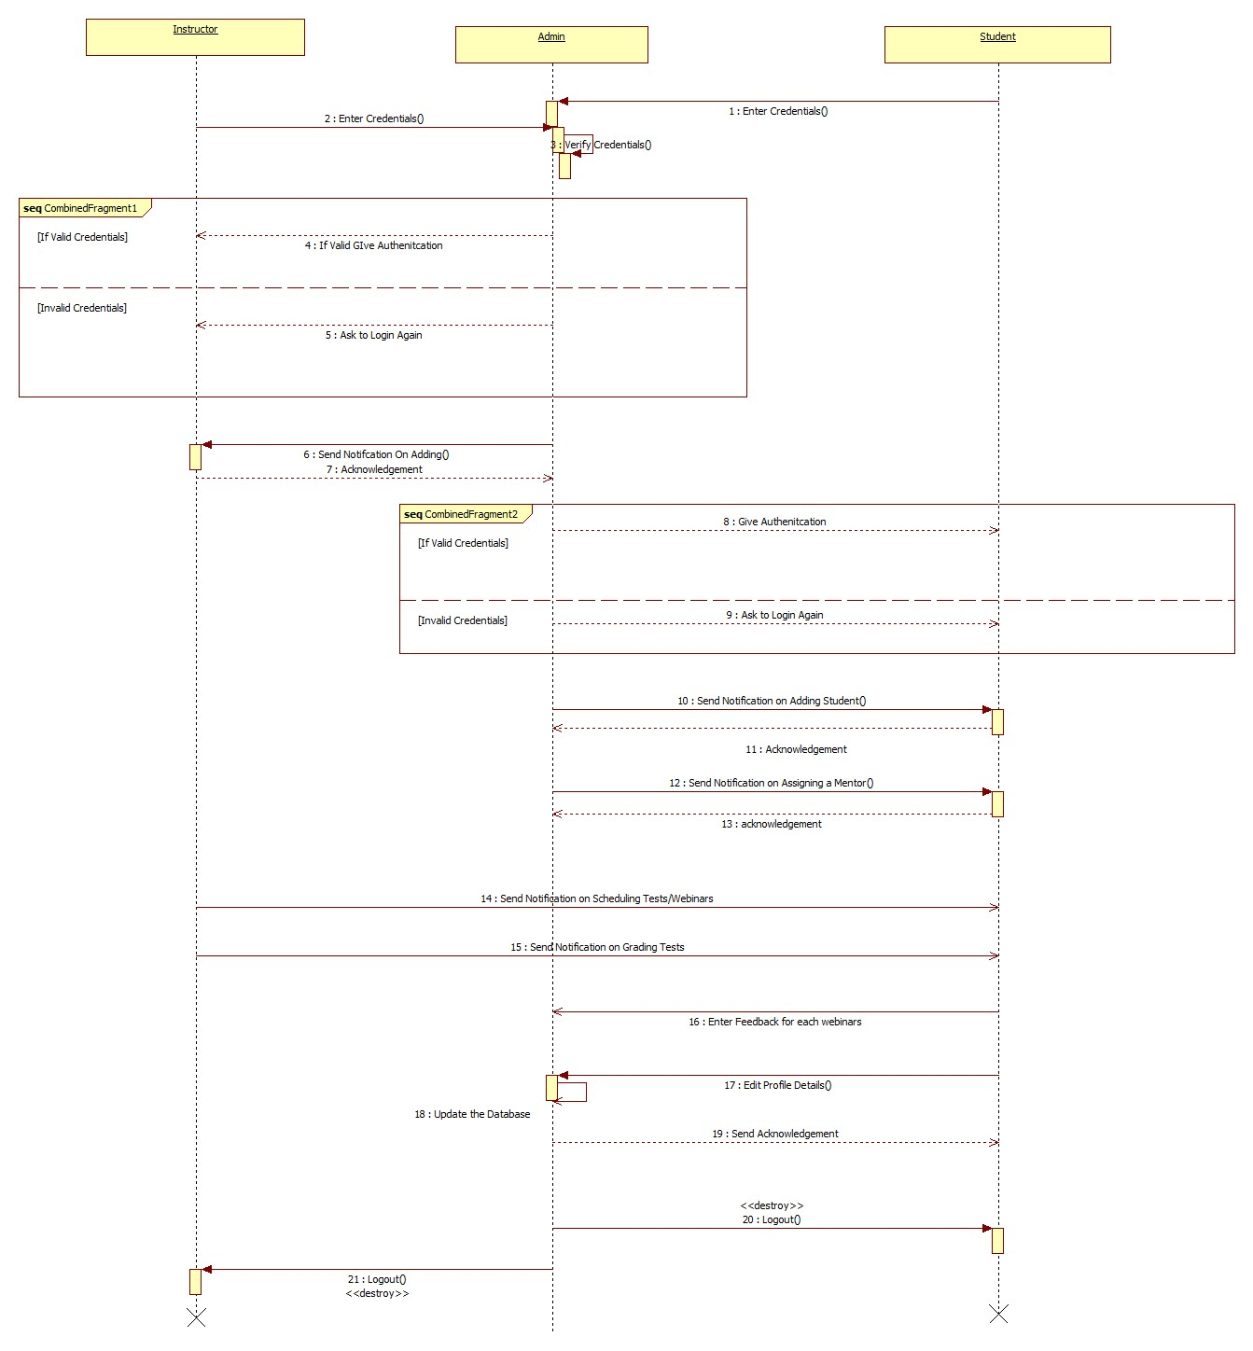

* 1. **Activity diagram**

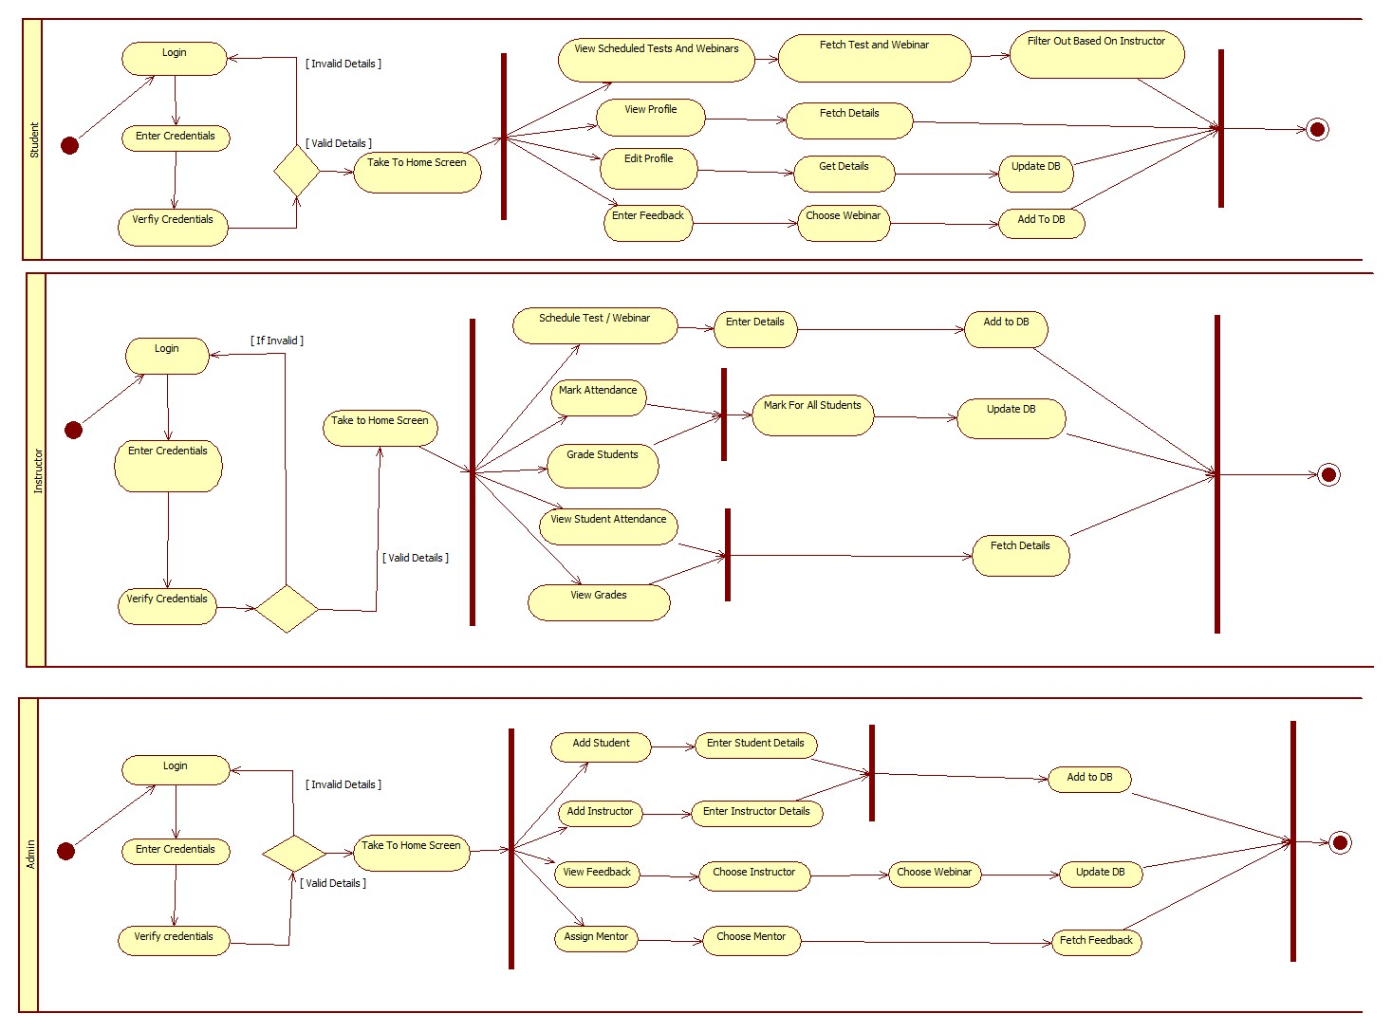

1. **APPENDICES**

**Appendix A: To be determined list**

The size of the database is to be determined based on the number of users (both teachers and students) ,tests ,webinars feedbacks, and answer scripts data. The extension of features will be possible only after knowing the reach and responses of the active users.

# Appendix B: Analysis Models

The entity-relationship model for the product functions have been shown in the above section (2.2 Product functions).